BUSINESS INSIGHT REPORT

Dataset Name
Global Sales & Financial Performance — Interactive Sales Dashboard
Student Name
[Insert your full name]
[Insert Course / Module Name]
[Insert Submission Date]

2. Introduction
This report presents a business analysis of the Global Sales & Financial Performance dataset, drawn from an interactive Power BI sales dashboard covering transactions across product categories, regions, employees and time. The dashboard tracks orders placed between 2018 and 2024 and consolidates them into headline financial metrics, category and regional breakdowns, monthly trends, employee contribution, and product-level detail.
The purpose of this analysis is to identify which parts of the business are performing well and which are not, so that management can make informed decisions on inventory, marketing, regional expansion, staffing and product strategy. The sections that follow walk through the dashboard's KPIs, then break performance down by product category, month, region and employee, and close with a set of business recommendations grounded in these findings.

3. Dashboard Overview
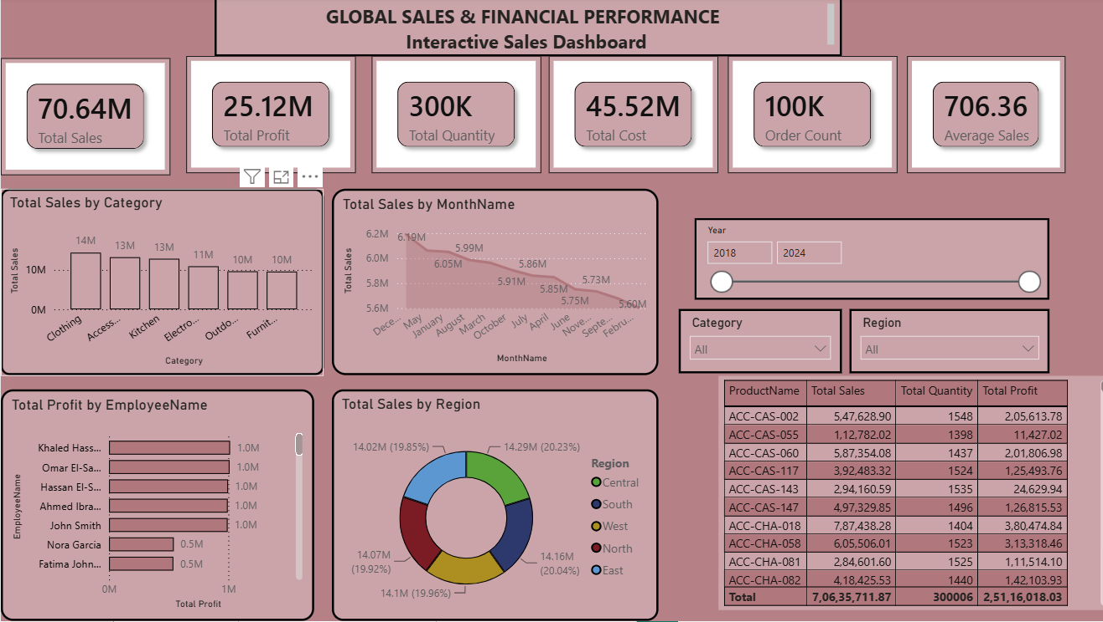

Dashboard Description
The Interactive Sales Dashboard opens with six KPI cards — Total Sales, Total Profit, Total Quantity, Total Cost, Order Count and Average Sales — giving an at-a-glance summary of overall performance. Below the KPIs, a column chart breaks total sales down by product category, a line chart tracks total sales by month, and a donut chart shows the regional split of sales. A horizontal bar chart ranks employees by total profit generated, and a detail table lists total sales, quantity and profit for individual products. Slicers for Year (2018–2024), Category and Region let users filter every visual interactively.

4. KPI Analysis
70.64M  Total Sales | 25.12M  Total Profit | 300K  Total Quantity
45.52M  Total Cost | 100K  Order Count | 706.36  Average Sales

Overall, the business generated 70.64M in total sales against 45.52M in total cost, producing 25.12M in profit — a gross margin of roughly 35.6%. With 100K orders totaling 300K units sold, the average order carries about 3 units, and the average sale per order is 706.36. This points to a healthy, moderately-priced volume business rather than either a low-margin high-volume model or a high-ticket low-volume one.

5. Product Category Performance Analysis
Product Category | Total Sales
Clothing | 14M
Accessories | 13M
Kitchen | 13M
Electronics | 11M
Outdoor | 10M
Furniture | 10M

Clothing is the top-performing category at 14M in sales, narrowly ahead of Accessories and Kitchen, which are tied at roughly 13M each. Electronics trails at 11M, while Outdoor and Furniture are the weakest categories, each contributing about 10M. The spread between the strongest and weakest categories is around 4M — roughly 28% lower — indicating category performance is fairly balanced with Clothing as a modest leader rather than one category dominating the mix.

6. Monthly Sales Trend Analysis
Monthly total sales range from a high of about 6.19M down to a low of about 5.60M over the period shown, a spread of roughly 0.6M. The trend line slopes gently downward across the months plotted rather than showing sharp seasonal peaks or troughs, suggesting demand is relatively stable month to month with a mild softening trend rather than pronounced seasonality. This is worth monitoring: a sustained gradual decline, even a small one, can compound over multiple quarters if the underlying cause (e.g. demand saturation, competitive pressure, or reduced marketing activity) is not addressed.

7. Regional Sales Analysis
Region | Total Sales | % of Total
Central | 14.29M | 20.23%
East | 14.16M | 20.04%
West | 14.10M | 19.96%
North | 14.07M | 19.92%
South | 14.02M | 19.85%

Regional sales are exceptionally well balanced: all five regions sit within a narrow 19.85%–20.23% share of total sales, each close to the 20% mark expected from an even five-way split. Central leads narrowly at 14.29M (20.23%), while South is the lowest at 14.02M (19.85%) — a gap of only about 270K, under 2%. This even distribution suggests no single region is significantly under-served or over-relied upon, though it also means there is no clear standout region currently driving disproportionate growth.

8. Employee Performance Analysis
Employee Name | Total Profit
Khaled Hassan | 1.0M
Omar El-Sayed | 1.0M
Hassan El-Sayed | 1.0M
Ahmed Ibrahim | 1.0M
John Smith | 1.0M
Nora Garcia | 0.5M
Fatima John... | 0.5M

Five employees — Khaled Hassan, Omar El-Sayed, Hassan El-Sayed, Ahmed Ibrahim and John Smith — each generate approximately 1.0M in profit and form a clear top performance tier. Nora Garcia and Fatima John... trail noticeably at around 0.5M each, roughly half the profit contribution of the top tier. This gap is worth investigating: it may reflect differences in tenure, territory or account size rather than effort, but it is large enough (50%) to warrant a closer look before drawing conclusions.

9. Business Recommendations

Inventory Planning
- Prioritize stock and reorder frequency for Clothing, Accessories and Kitchen — the top three categories account for the bulk of sales, and stockouts here carry the highest opportunity cost.
- Review Outdoor and Furniture inventory levels; their lower sales volume (10M each) may allow for leaner stock without risking availability.

Marketing Strategy
- Investigate the cause of the gentle month-over-month sales decline (6.19M down to 5.60M) — check whether it lines up with reduced promotional spend, pricing changes, or increased competition.
- Consider a targeted campaign to re-accelerate growth, since no strong seasonal peak is currently offsetting the downward drift.

Regional Expansion
- Because all five regions perform within a tight 19.85%–20.23% band, there is no urgent regional gap to close; instead, evaluate whether any region has untapped market size that could unlock growth beyond the current even split.
- South (19.85%) is the softest region — a small, low-risk pilot campaign there could test whether it has more headroom than the other regions.

Employee Performance
- Pair Nora Garcia and Fatima John... with top performers (Khaled Hassan, Omar El-Sayed, Hassan El-Sayed, Ahmed Ibrahim, John Smith) for mentoring, since the top tier generates roughly double the profit.
- Review whether the gap is due to account/territory assignment rather than performance before adjusting incentive structures.

Product Portfolio
- Products such as ACC-CHA-018 (787,438.28 in sales, 380,474.84 in profit — roughly a 48% margin) are strong candidates to feature more prominently or bundle with lower-margin items.
- Low-margin products such as ACC-CAS-055 (112,782.02 in sales but only 11,427.02 in profit, about a 10% margin) should be reviewed for pricing or cost adjustments.

Customer Targeting
- Use the balanced regional split to run consistent, nationwide campaigns rather than region-specific ones, since no region is significantly underperforming.
- Target promotions around the Clothing, Accessories and Kitchen categories, where customer demand is demonstrably strongest.

